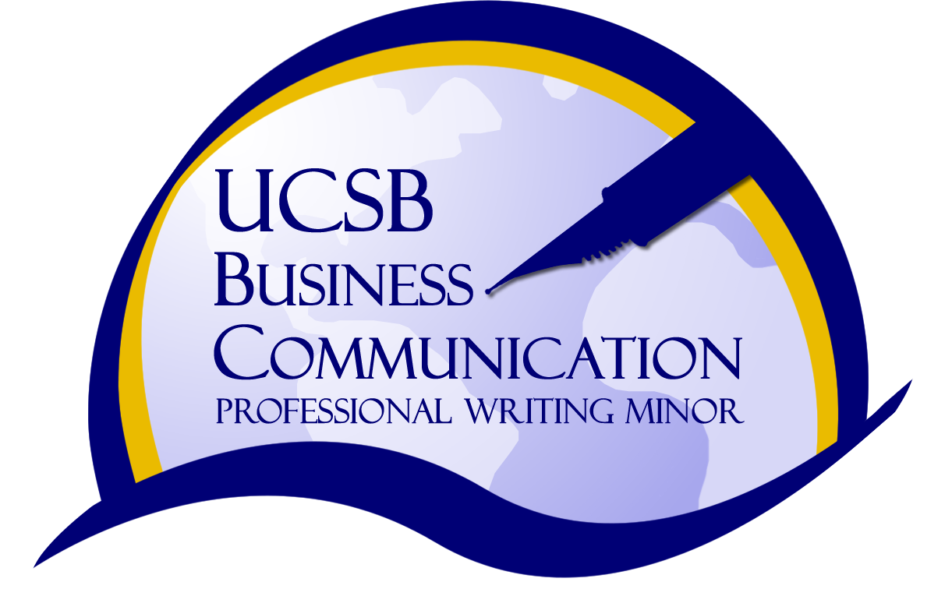
The Business Communication Track/
Professional Writing Minor

Development of written, visual, oral and collaborative skills for the workplace (business, government, non-profit organizations), with a focus on design, development, and re-purposing of hardcopy and new media documents. A final portfolio will include examples of a variety of professional genres―such as letters, e-mails, status reports, proposals, news releases, feasibility reports, policies and procedures, brochures―presented in both print and digital form.

Which students might want to enroll in this track?
*Those interested in refining workplace communication—especially in business, governmental, and
non-profit organizations. Students will work collaboratively with community organizations on
service learning projects.
*Those interested in entrepreneurial and managerial work, who will need to enhance leadership skills
with communication skills, and students who plan for graduate MBA or MPA degrees.
*Those interested in sustainability careers, who want to explore the professional skills needed,
including social media tools, to engage employees and citizens.

What do we do in the business communication courses?
The capstone courses in business communication seek to assist students with the important transition from school to work. We build on the academic skills gained throughout students’ undergraduate studies and the applied, professional skills gained through our internship and other work experiences.

By using case studies, we expand students’ understanding of workplace issues, especially in the areas of business ethics, cross-cultural understanding, and crisis management. By working collaboratively on service learning projects for community “clients,” students will work on writing, speaking, and project management skills-- and contribute to our local community before graduation.

Each student will have an opportunity to study new media tools along with traditional print media, and will construct both a digital and hardcopy portfolio.

Where will students get internships?
*Local businesses, including public relations firms, publishing, and accounting
organizations such as Yardi Systems, DAVIES Communication, The Independent, UCSB Accounting Controls, Citrix Online
*Local environmental businesses and organizations, including Tetra Tech, Green2Gold,
Allen Associates, Kids in Nature, The Center for Urban Agriculture
*Local government and non-profit organizations, including the City of Santa Barbara,
United Way, Direct Relief, Family Services Agency, Creative Wealth International

Which courses are recommended?
Writing 107B, Business and Administrative Writing (formerly 109EC)
Writing 107J, Journalism and News Writing (formerly 109JW) Writing 107P, Writing for Public Relations
Writing 107M, Magazine Writing for Publication Writing 107T, Technical Writing
Writing 107G, Writing for Global Careers (formerly 109GS) Writing 105M, Multimedia Writing
Writing 105PS, Writing for Public Speaking Writing 105S, Writing About Sustainability
Writing 109ES, Writing for Environmental Studies

